1. Introduction
Cryptographic hash functions are fundamental components of modern information security systems. They are used for ensuring data integrity, password protection, digital signatures, and message authentication. A cryptographic hash function converts input data of arbitrary length into a fixed-length output called a hash or digest.
One of the most widely used cryptographic hash functions today is SHA-256, which belongs to the SHA-2 family designed by the National Security Agency (NSA). SHA-256 generates a 256-bit output and is commonly used in secure communication protocols, blockchain systems, password storage mechanisms, and digital certificates.
The goal of this project was to implement the SHA-256 cryptographic hash function from scratch, following the FIPS 180-4 specification. Based on this implementation, additional cryptographic constructions were developed, including HMAC (Hash-based Message Authentication Code), PBKDF2 (Password-Based Key Derivation Function 2), and HKDF (HMAC-based Key Derivation Function).
All cryptographic operations in this project were implemented without using external cryptographic libraries, as required by the assignment. This allowed us to gain a deeper understanding of how modern cryptographic algorithms work internally.
In addition to implementing these algorithms, we also developed several practical applications demonstrating their use in real-world systems. These include a hashing tool, an HMAC authentication tool, a secure password storage system using PBKDF2, a key derivation system using HKDF, and a file integrity verification tool.
Through this project, our team gained practical experience in implementing cryptographic algorithms and understanding the role they play in modern security systems.

Section 2: SHA-256 Implementation
Our implementation of SHA-256 follows the FIPS-180-4 specification and processes messages in 512-bit blocks.
The algorithm starts by initializing eight 32-bit hash values and defining 64 round constants. Logical functions such as ROTR, SHR, Ch, Maj, Σ and σ are implemented to perform bitwise operations required by the compression function.
The message is padded before hashing so that the final length becomes a multiple of 512 bits. Padding consists of adding a single bit “1”, followed by zeros, and finally the original message length encoded as a 64-bit integer.
The compression function processes each 512-bit block using 64 rounds of operations.
Below is the core implementation used in our project.
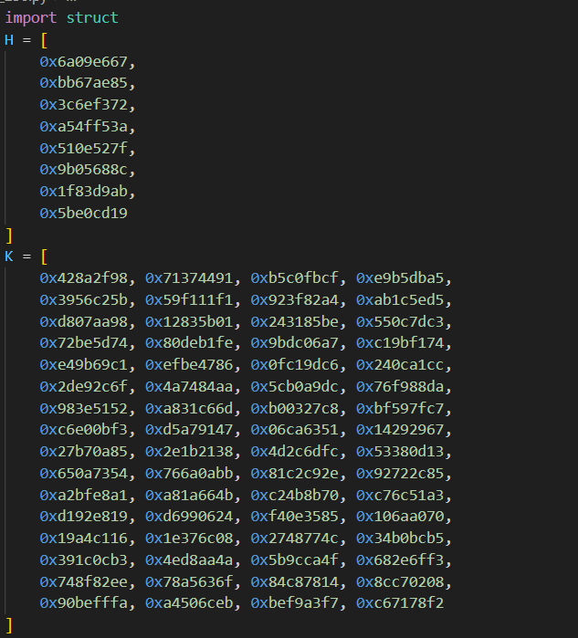
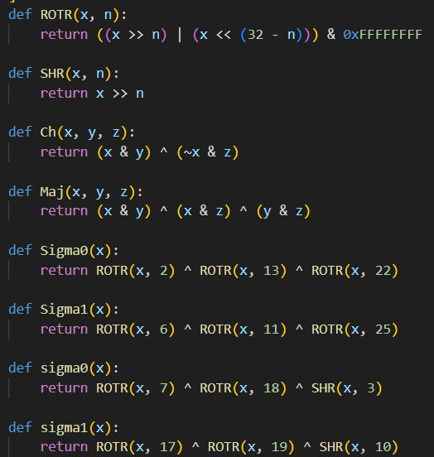
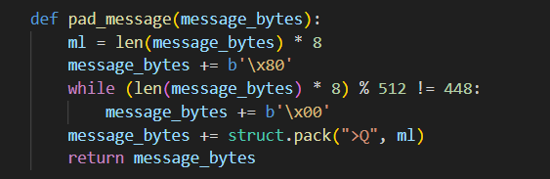
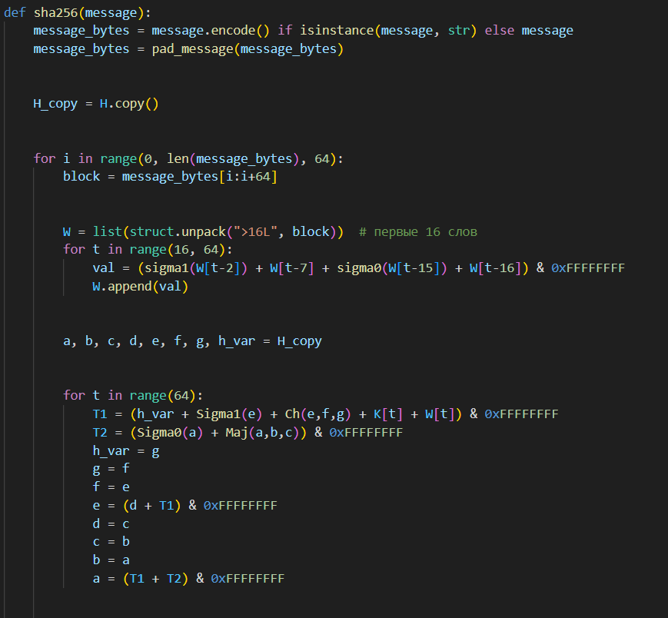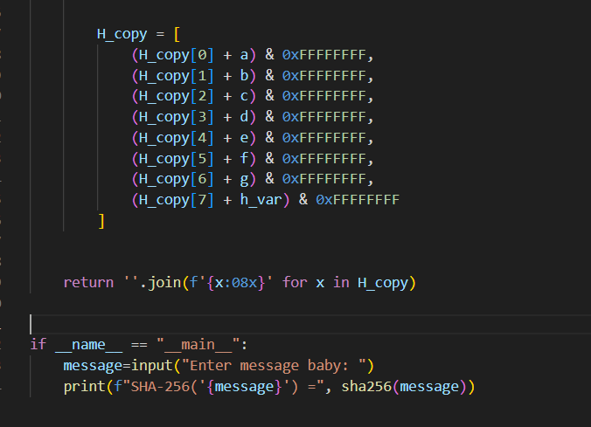

Section 3: HMAC Implementation
HMAC (Hash-based Message Authentication Code) is used to verify both message integrity and authenticity.
The algorithm uses two padded keys:
ipad = 0x36 repeated 64 times
opad = 0x5c repeated 64 times
The HMAC computation follows the standard formula:
HMAC(K,M) = H((K ⊕ opad) || H((K ⊕ ipad) || M))
The key is first normalized to the SHA-256 block size (64 bytes). If the key is longer than the block size, it is hashed. If it is shorter, it is padded with zeros.
Our implementation performs the following steps:
- Normalize key length
- Generate inner padded key
- Compute inner SHA-256 hash
- Compute final HMAC value
Below is the implementation used in our project.
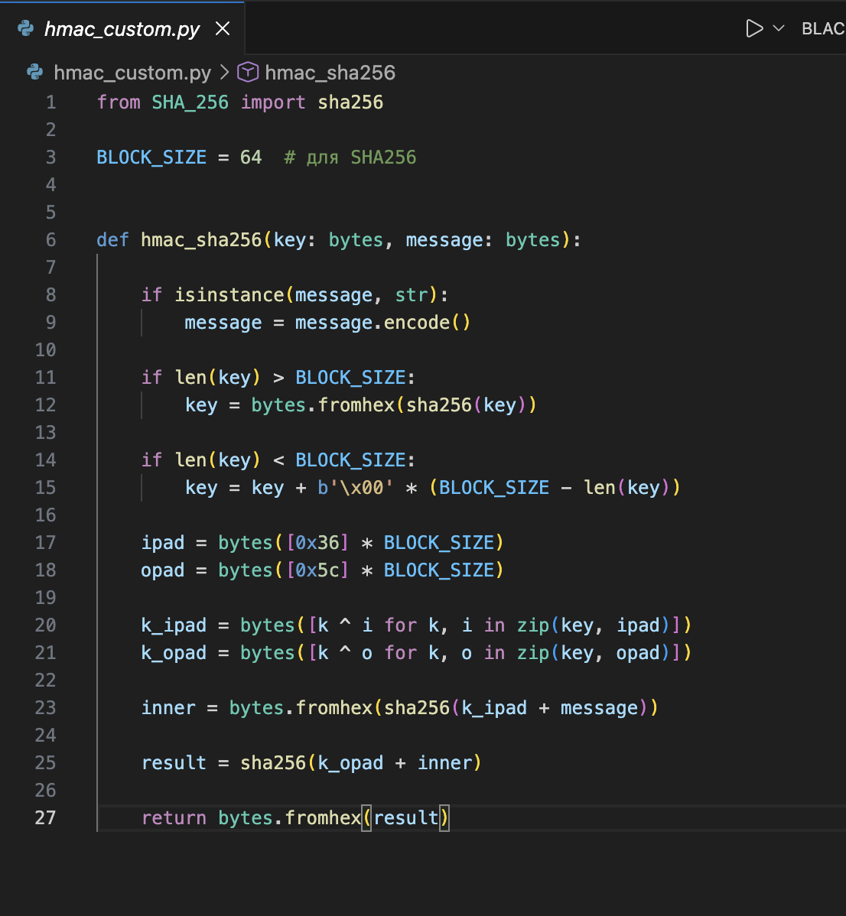

Section 4: Key Derivation Functions

PBKDF2 Implementation
PBKDF2 is used to derive a secure cryptographic key from a password.
The algorithm applies repeated HMAC operations to slow down brute-force attacks.
The function used in our implementation is:
pbkdf2(password, salt, iterations, key_length)
Steps of the algorithm:
- Calculate number of blocks
- Compute U1 using HMAC
- Repeatedly compute Ui
- XOR all intermediate values
- Concatenate the results
The implementation in our project is shown below.
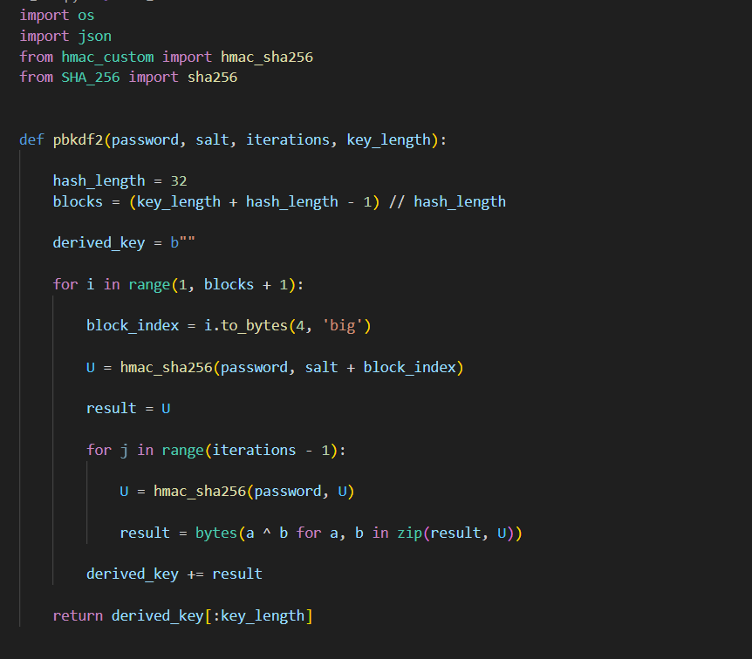
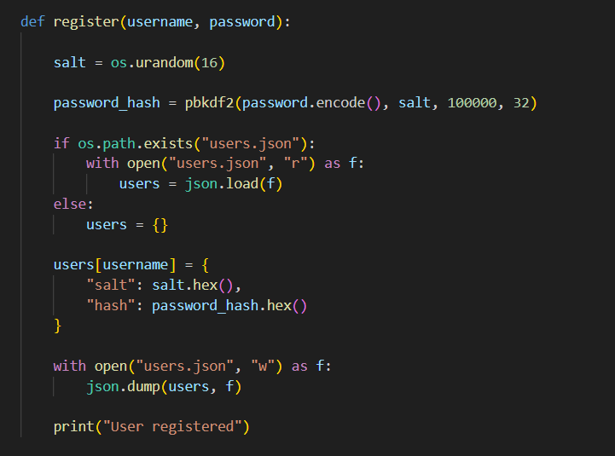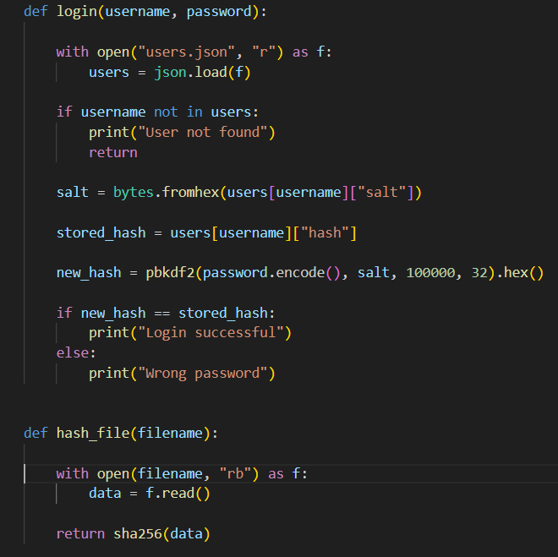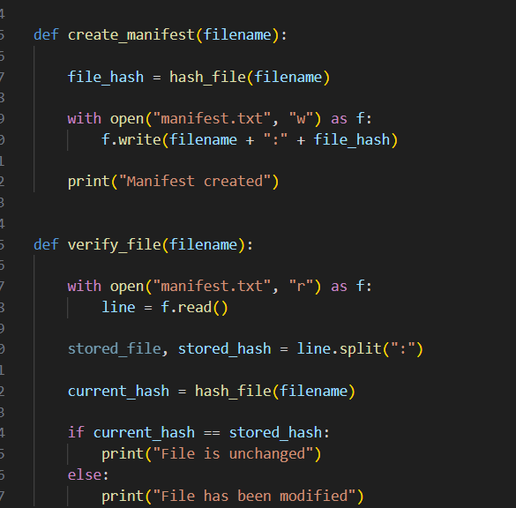

HKDF Implementation
HKDF is another key derivation function used to generate cryptographic keys from initial key material.
The algorithm consists of two phases:

Extract
PRK = HMAC(salt, input_key_material)

Expand
T(i) = HMAC(PRK, T(i-1) || info || counter)
Below is the implementation used in our project. 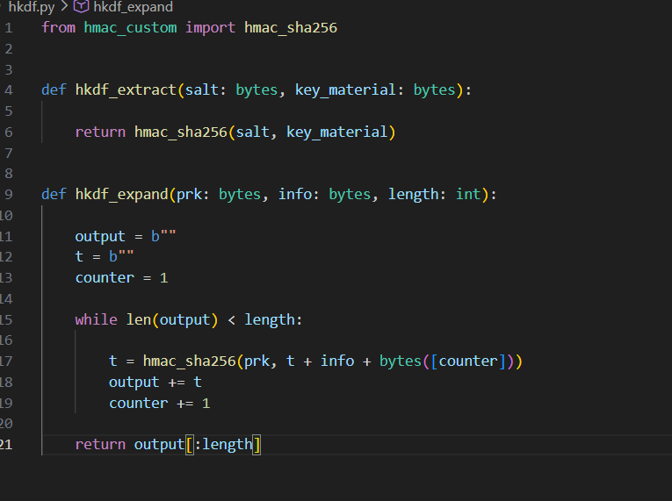

Section 5: Application Features
The project includes a command-line interface application that demonstrates practical uses of the implemented cryptographic algorithms.
The main application file provides the following menu:
1 – Generate HMAC
2 – Verify HMAC
3 – Register user
4 – Login user
5 – Create file hash
6 – Verify file
The CLI application coordinates the interaction between different modules.
print("1 – Generate HMAC")
print("2 – Verify HMAC")
print("3 – Register user")
print("4 – Login user")
print("5 – Create file hash")
print("6 – Verify file")

Password Manager
The password manager uses PBKDF2 with a randomly generated salt.
Each user entry stores:
username
salt
password_hash
Example stored record:

File Integrity Checker
The application can compute the SHA-256 hash of a file and store it in a manifest file.
Example manifest entry:
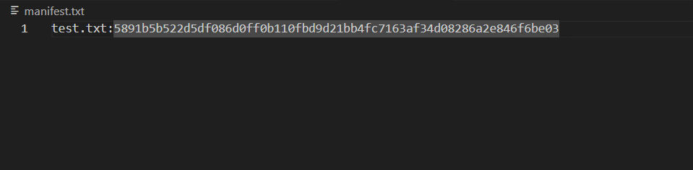manifest
This allows the system to detect if the file has been modified.

Section 6: Testing and Validation
Several tests were performed to validate the correctness of the implementation.
SHA-256 was verified using official NIST test vectors.
Example:
Input
abc
Output
ba7816bf8f01cfea414140de5dae2223b00361a396177a9cb410ff61f20015ad
Additional tests included:
• verifying HMAC authentication
• testing password storage and login
• checking file integrity detection
• demonstrating the avalanche effect.

Section 7: Security Analysis
SHA-256 provides strong cryptographic properties including collision resistance and preimage resistance.
HMAC protects messages from forgery and ensures authenticity when a secret key is used.
PBKDF2 strengthens passwords by applying repeated hashing and salting, which makes brute-force attacks significantly slower.
HKDF allows secure generation of cryptographic keys from shared secrets.
Together, these mechanisms provide a strong foundation for secure authentication and data integrity systems.

Section 8: Challenges and Lessons Learned
During development we faced several challenges.
The main difficulty was implementing cryptographic algorithms without using existing libraries. This required careful implementation of bitwise operations and correct handling of byte arrays.
Another challenge involved debugging issues related to data encoding and conversions between strings, bytes, and hexadecimal representations.
Despite these difficulties, the project significantly improved our understanding of cryptographic primitives and secure software design.

Section 9: Conclusion
In this project we successfully implemented SHA-256, HMAC, PBKDF2, and HKDF from scratch.
The project also demonstrated practical applications of these algorithms including message authentication, password protection, key derivation, and file integrity verification.
Implementing these algorithms without cryptographic libraries allowed us to understand their internal structure and importance in modern cybersecurity systems.

Thank you for your attention.

Our passwords are now officially harder to break than our code.



